3x3 Observations: December 2009
MATH Department – 15 Classes

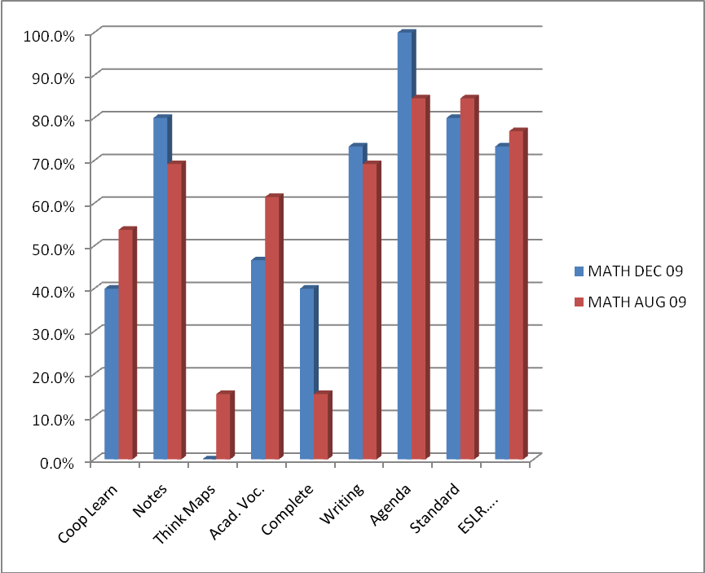
MATH | Coop Learn | Notes | Think Maps | Acad. Voc. | Complete Sentences | Writing | Agenda | Standard | ESLR….
Dec 09 | 40% | 80% | 0% | 47% | 40% | 73% | 100% | 80% | 73%
Aug 09 | 54% | 69% | 15% | 62% | 15% | 69% | 85% | 85% | 77%

